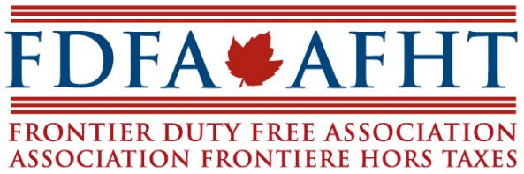
SEMI-ANNUAL / HILL DAY PROGRAM
MAY 14-16, 2019

Tuesday, May 14
2pm-4pm: Board Meeting – Impact/FDFA Offices
5pm-6pm: Hill Day Briefing – Penthouse B, Sheraton Hotel

Wednesday, May 15
7am-8am: Operators’ Breakfast – Penthouse B, Sheraton Hotel
8am–1pm: Operators’ Meeting/Lunch – Penthouse A/B, Sheraton Hotel
1pm-5pm: Meetings on the Hill
5pm-7pm: Reception – Room 330 Wellington Building

Thursday, May 16
7am-9am: Operators’ Breakfast – Albert Room, Sheraton Hotel
9am-3pm: Meetings on the Hill
Lunch: drop in lunch available at Impact/FDFA Office

