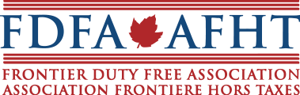

May 9, 2018
Ottawa, Ontario

Dear Sir / Madam,

The Board of Directors of the Frontier Duty Free Association (FDFA) would like to thank you for submitting your candidacy for the open Executive Director position. The selection committee is currently reviewing all applicants and expects to make it’s decision by May 31, 2018.
The FDFA will notify all applicants of the outcome of the selection process after engagement documents have been signed with the successful proponent.

