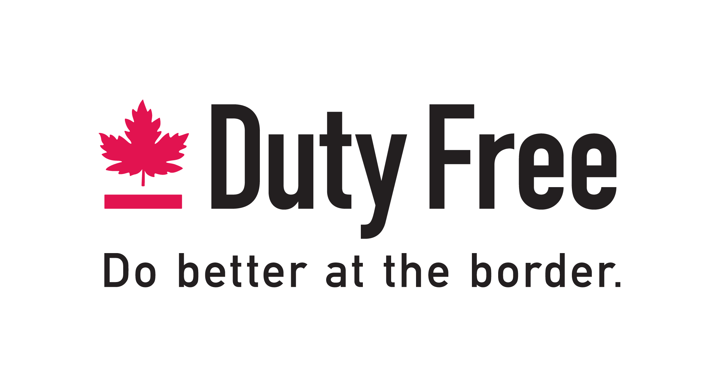

Executive Evaluation
(Evaluation documents, guideline and revised timeline)

Committee Members: Allison Boucher
Peter Brain
Ralph Caria
Pierre Guay
Jeff Butler
Simon Resch

Mandate and Overview of Work
The mandate of the committee is “to evaluate the operational requirements of the LBDF industry and the FDFA from an executive perspective and to make strategic recommendations to the Board of Directors (B.O.D.) concerning executive management and direction; to clarify the role and job description of an Executive Director/management function within the FDFA; and to develop and evaluate options for association continuity in various executive management scenarios”

To assist the committee in fulfilling its’ mandate, a standardized alternative development and evaluation protocol has been created to guide the committee through the various stages of discovery/development, evaluation and vetting, and in making its’ final recommendation to the Board of Directors.

Phase 1 - development of alternatives
- The master management categories for alternative development and evaluation are:
- EXECUTIVE DIRECTOR - this category will be focused on developing and evaluating alternatives (candidates) to fill a single, full time, Executive Director of the FDFA position, and how this alternative will best suit the needs of the Association. Ancillary areas for consideration are how the B.O.D will interact with the Executive, how pre-existing employee(s) will interact with the Executive, program and activity continuity in light of 2 year B.O.D. terms and whether the FDFA has the financial resources required to support the preferred alternative.

- SPECIALIZED INDUSTRY PARTNERSHIP - this category will be focused on developing and evaluating options that would see the FDFA operations enter into a management partnership with an established (or potential) Executive Management firm (one with a preferred bias toward GR activity), and how this alternative will best suit the needs of the Association. Ancillary areas for consideration are how pre-existing employee(s) will interact with the Executive Management firm, how the B.O.D. will interact with the Executive Management firm, how the FDFA will retain control of its’ operations and remain (semi)autonomous, program and activity continuity, and whether the FDFA has the financial resources required to support the preferred alternative.

- B.O.D. + STRATEGIC OUTSOURCING - this category will be focused on developing and evaluating options for operations, activity and program continuity under a B.O.D. + existing employee(s) management scenario, and how this alternative best suits the needs of the Association. Ancillary areas for consideration are how the B.O.D. and existing employee(s) will interact, B.O.D. workload, B.O.D. terms (length in years) + suitable availability, identification of operational needs, resource allocation and strategic outsourcing of program work (GR, marketing, etc.) as needed, and how this option will impact the financial resources of the FDFA.

- To develop and evaluate alternatives under these master management categories, the committee members will break out into sub groups consisting of 2 committee members each. The subgroups will develop a minimum of 3 alternatives under their respective categories for advancement to the comprehensive evaluation phase. The following subgroup composition is recommended but is open to variance based on committee feedback:

- Executive Director - Allison Boucher, Jeff Butler
- Specialized Industry Partnership - Ralph Caria, Simon Resch
- B.O.D + Strategic Outsourcing - Peter Brain, Pierre Guay

Phase 2 - Evaluation and Selection of Preferred Alternative.
- Once the subgroups have developed a suitable suite of alternatives and have evaluated those alternatives according to the criteria, the alternatives + any corresponding development/vetting material should be submitted to the committee chair for distillation and distribution.
- The committee chair will then arrange to have the committee as a whole evaluate each of the advanced alternatives according to the same evaluation criteria. This secondary, comprehensive evaluation of alternatives should allow the committee to identify 1 preferred alternative and 1 secondary alternative for advancement to the B.O.D. as the strategic recommendation for Executive Management.
- The B.O.D. will then make its decision on whether to engage the committee’s recommendation or whether to instruct the committee to continue with its work.

Resources and Materials Needed
- An internet connection and online video conferencing capability - for the Executive Director and industry partnership subgroups, the ability to conduct an interview via online video conferencing is a cost and time effective way to conduct live interviews. This is the preferred method for interviewing in the phase 1 developmental stage.
- Mandatory prerequisites, discovery questions and evaluation criteria.
- Committee budget and checklists (checklists to be developed as needed)
- Question/answer + guidance protocols
- Delineation of FDFA GR needs and activities
- FDFA annual budget
- Cost assessment and resource allocation for development of a national advertising initiative, including the engagement of a “headhunter” firm (if necessary)

Revised Timeline
- By April 1, 2018
- Standardized evaluation package
- Identification of category sub groups
- Question/answer + guidance protocol for sub groups

- April 1 - April 30, 2018
- Sub groups to develop and vet a suite of alternatives under their respective management categories
- Sub groups to advance the alternatives to committee chair for distillation and distribution to the committee
- The timeline does not provide much forgiveness - as such, the committee as a whole is requested to briefly review the timelines at scheduled meetings, and adjust when and if necessary to ensure adequate time for the process and any unforeseens.

- May 1 - May 31, 2018
- Committee as a whole to perform secondary evaluations of the preferred alternatives advanced from each subgroup, using the same online interviewing capability when and if necessary
- Committee to select it’s preferred and secondary alternatives based on scores achieved in the evaluation process and advance these to the B.O.D. as the strategic recommendation
- B.O.D. to perform its’ work (live interviews, engagement letter, employment agreement, etc.) OR send back to the committee for continuation.

National Advertisement Placement and Framework
- National advertisement placement: FDFA website + any able, participating member website, FDFA social media platforms + any able, participating member social media, placement in major national publications (provisional budget is $2,500, committee should review at the next scheduled meeting). Recommendations for major national publications: Globe and Mail, National Post, Le Devoir.

- Resumes, CVs and Information collection: Recommend that we create a new email address for respondents to send their information and enquiries (we may still have an active one from Laurie - Simon to enquire with Allison)

- Information package for proponents + translation services: an informational brief that summarizes relevant information to also be made publicly available on fdfa.ca and social media (and able, participating member’s sites...) Recommended to use the services of a professional translator for distribution in Quebec.

- Information Management: depending on volume of responses and ability to answer in timely fashion, it’s recommended that Allison administer the new email address and be the primary contact for information distribution. Committee chair to function as relief/secondary point of contact.

- Submissions meeting the prerequisites: to be uploaded to the FDFA committee section for access and review by committee members.

