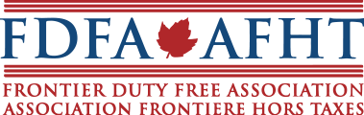

May 9, 2018
Ottawa, Ontario

To whom it may concern,
The Frontier Duty Free Association (FDFA) is pleased to announce it is currently reviewing partnership proposals for organization-led executive management and direction, with a strong foundation in Government Relations, and would like to invite your firm to submit a proposal for consideration.
Formed in 1986, the FDFA is the voice and resource of the Canadian duty free industry, headquartered in Ottawa. The FDFA is a dynamic and progressive not for profit industry association, governed through an elected Board of Directors.
For more information on this opportunity, the FDFA and the Canadian duty free industry, please visit http://fdfa.ca/ or contact our Ottawa office at aboucher@fdfa.ca
Submissions will be accepted up to May 31, 2018. The FDFA would like to thank all those in advance for your submissions and will notify all applicants of the outcome once a proposal has been selected.

