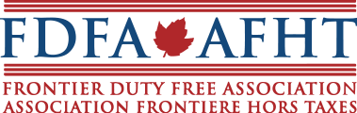

April 9th, 2018
Ottawa, Ontario

The Board of Directors of the Frontier Duty Free Association (FDFA) is pleased to hereby announce it is undertaking a national search for Executive Management with a focus on Government and public relations.
Formed in 1986, the FDFA is the voice and resource of the Canadian duty free industry, headquartered in Ottawa. The FDFA is a dynamic and progressive not for profit industry association, governed through an elected Board of Directors.
Qualified individuals/firms are invited to submit CV’s together with salary/fee expectations to the FDFA by April 30th, 2018.
For more information on this opportunity, the FDFA and the Canadian duty free industry, please visit http://fdfa.ca/ or contact our Ottawa office at admin@fdfa.ca

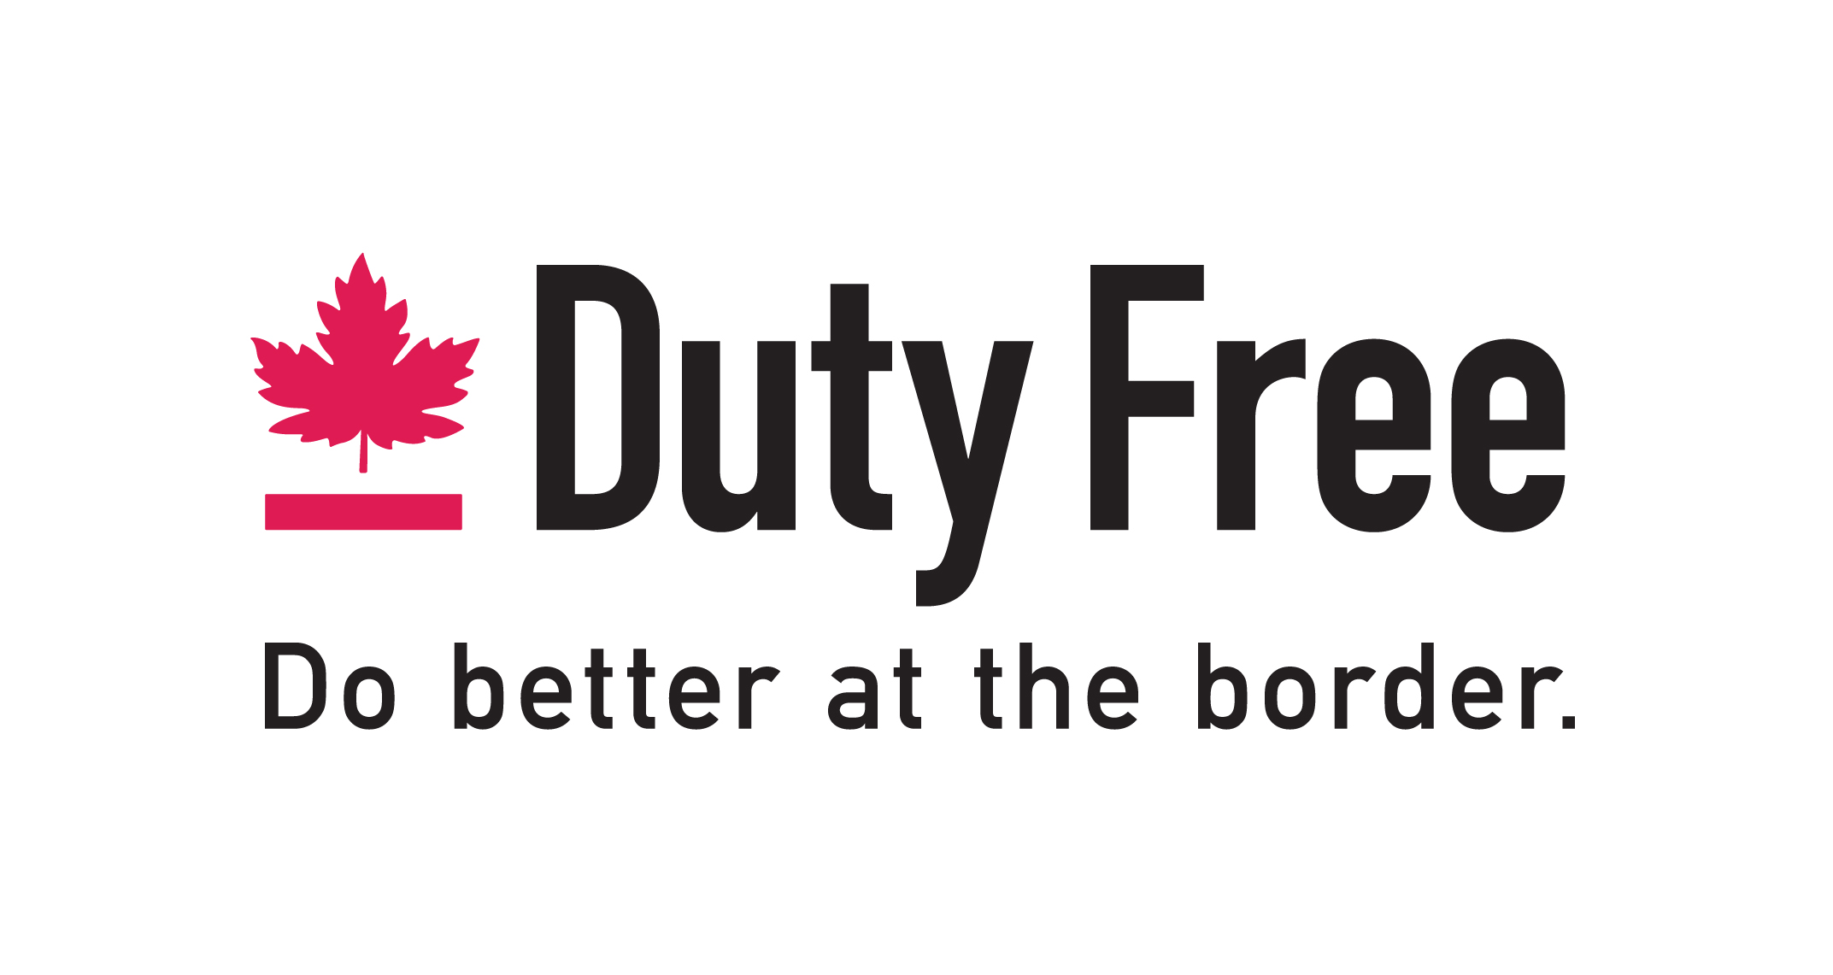

PURPOSE
The Frontier Duty Free Association promotes the development of Canada's land border duty free industry by acting as a voice, advocate and business resource for member stores.

The FDFA fosters a highly competitive Canadian Land Border Duty Free Industry that is vibrant, creative, progressive and best-in-class among land border and airport duty free retailers around the world.

Overview
Since the inauguration of the federal land border duty free shop program in 1982, duty free shops have been an integral part of the Canadian tourism experience.
The federal duty free shop program, which is an extension of the many services provided to tourists visiting Canada, was created to attract more foreign visitors by offering significant tax and duty free savings on the purchase of a host of consumer items.

SCOPE

Active membership in the FDFA includes 26 Canadian land border duty free shops, and associate members consist of Canadian airport and U.S. land border duty free shops, as well as trade supplier members.
The FDFA’s primary activities include:
- Liaise between active members and the federal government’s Duty Free Shop Program.
- Dynamic Government Relations, with a core focus on the following departments and agencies: CBSA, Transport Canada, Destination Canada, Finance Canada, Health Canada, Stats Canada.
- Represent the FDFA and its membership to other industry related associations such as the Retail Council of Canada and the Tourism Industry Association of Canada.
- Oversee consumer awareness via our consumer website, social media and blogs.
- Facilitate overall communications between the Association, it’s membership and the public at large.
- Government and media monitoring.
- Direct and oversee the FDFA annual convention and trade show.

OPPORTUNITY
The FDFA is currently undertaking a national search to fill it’s Executive Management position. The position reports to an elected Board of Directors and is responsible for directing the day to day affairs of FDFA activities, program development and advancement of the duty free industry’s interests at the national level.
To be effective, the ideal proponent will possess the combination of skills necessary to propel the national duty free industry forward in a complex, highly regulated and evolving environment.
Individual remuneration and employment benefits, or fee structure in the event a firm is selected, will be commensurate with prior experience and ability to satisfy the goals and objectives of the FDFA, as determined by the Board of Directors in its sole discretion.
The position will be both challenging and rewarding as the industry embraces legislative changes and advancements, and the FDFA develops to meet the needs of a diverse and varied membership.

CONDITIONS AND QUALIFICATIONS
The successful proponent will:
- Reside or be willing to relocate to the Ottawa area
- Be cleared to engage in lobbying activity with the Federal Government of Canada
- Have demonstrated experience in the field of Government Relations
- Possess strong networking and communication skills
- Be bilingual in both official languages
- Have prior experience working within a Board of Directors governed work environment and/or displays strong leadership and group management skills.
- Possess strong Public Relations and profile building skills
- Be visionary
- Be IT, digital and social media savvy

