March 1, 2018

Dear FDFA Member:

On behalf of the FDFA Board of Directors, I would like to share my sincere appreciation for your support of the FDFA in 2017. Your support and contribution for the FDFA is fundamental for the ongoing success and viability of the Canadian duty free industry. Your financial investment in membership enables us to strengthen our influence when voicing industry related concerns to all levels of government and industry stakeholders.

In 2017, the Board prioritized unity within the industry and accomplished significant progress towards this objective. With unity, we can make positive steps forward in a profitable and efficient manner, to benefit all our members. In 2018, the FDFA Board is focusing its energies, working for its members, charting a new course to remain viable for the next 30 years!

The FDFA recognized that our businesses have evolved and our convention must reflect these changes. Last year a committee was formed to fully evaluate and assess the convention format with a mandate to maximize value for both operator and supplier members. A new program and format was developed and we look forward to its implementation this November in Toronto. More information on the convention will be provided in the coming months. We look forward to seeing everyone there.

The FDFA is also undergoing an in depth analysis of its operations and managements as well. This will ensure that the membership will be effectively represented in the most efficient manner when required at both the industry and government relations level.

Thank you for your ongoing support.

Sincerely,
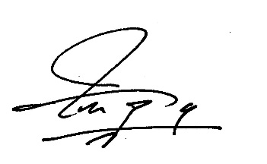
Abe Taqtaq, President

